Ray Originating at a Vertex
# Source: AI Source: Provided by: [Data Path: Persons Table -> ID Column: 1, Name_En Column: Motasem Essam] -> From: [ChatGPT] on [7/25/2026]
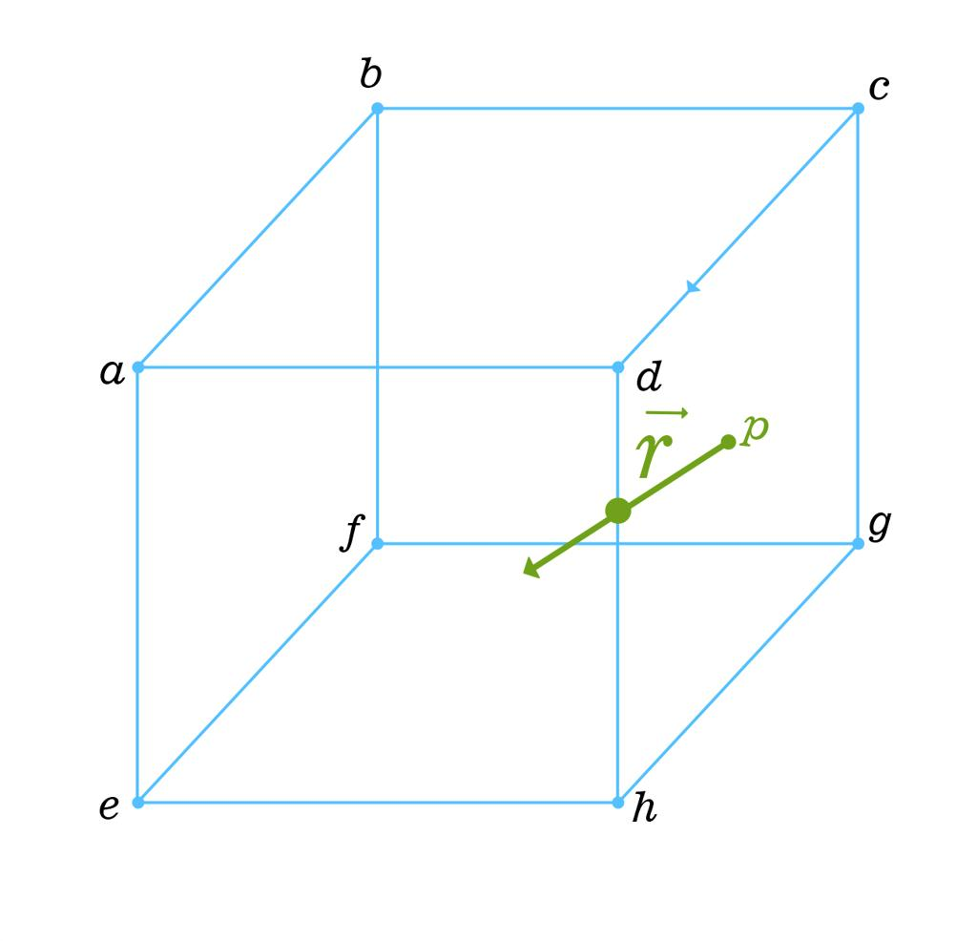

Definition
# Source: AI Source: Provided by: [Data Path: Persons Table -> ID Column: 1, Name_En Column: Motasem Essam] -> From: [ChatGPT] on [7/25/2026]
A ray originating at a vertex is a ray whose endpoint is a vertex of a three-dimensional geometric solid. From that vertex, the ray extends infinitely in one direction along a straight path.
A vertex is a corner of a solid, typically where its edges meet. The ray may extend outward from the solid, pass through its interior initially, or follow a direction that lies along an edge or within a face's plane.
The ray is not itself an edge of the solid because an edge is a finite segment, whereas a ray extends infinitely in one direction.
If $A$ is a vertex and $B$ is another point determining the direction, the ray is written as:
$$\boxed{\overset{→}{AB}}$$
Here, $A$ is the endpoint and $B$ determines the direction of the ray.

Simple definition
# Source: AI Source: Provided by: [Data Path: Persons Table -> ID Column: 1, Name_En Column: Motasem Essam] -> From: [ChatGPT] on [7/25/2026]
A ray originating at a vertex is a straight path that starts at a corner of a 3D solid and continues forever in one direction.
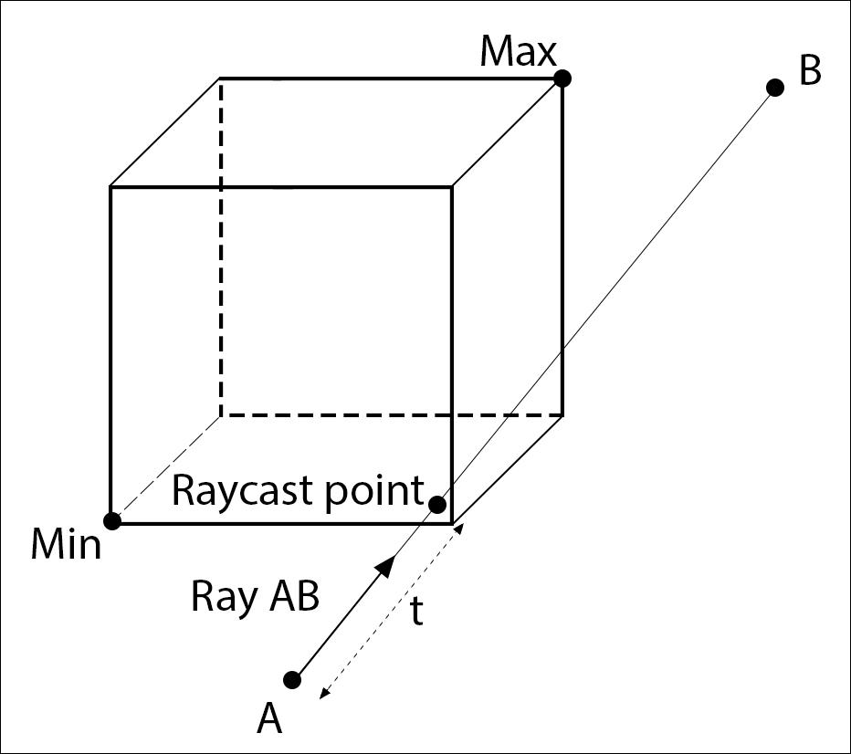
The ray begins at vertex A and extends indefinitely in the indicated direction.

Key characteristics
# Source: AI Source: Provided by: [Data Path: Persons Table -> ID Column: 1, Name_En Column: Motasem Essam] -> From: [ChatGPT] on [7/25/2026]
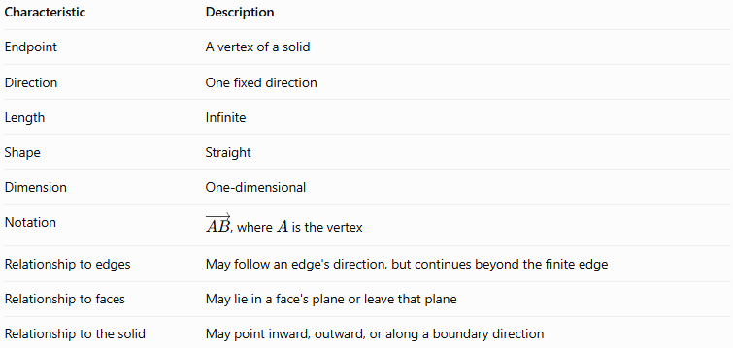
Characteristic | Description
Endpoint | A vertex of a solid
Direction | One fixed direction
Length | Infinite
Shape | Straight
Dimension | One-dimensional
Notation | $\overset{→}{AB}$, where $A$ is the vertex
Relationship to edges | May follow an edge's direction, but continues beyond the finite edge
Relationship to faces | May lie in a face's plane or leave that plane
Relationship to the solid | May point inward, outward, or along a boundary direction
Important: A vertex does not determine a unique ray by itself. Infinitely many different rays can originate at the same vertex because the direction can vary.

5. Types and examples of rays originating at a vertex

A. Ray extending outward from a vertex
# Source: AI Source: Provided by: [Data Path: Persons Table -> ID Column: 1, Name_En Column: Motasem Essam] -> From: [ChatGPT] on [7/25/2026]
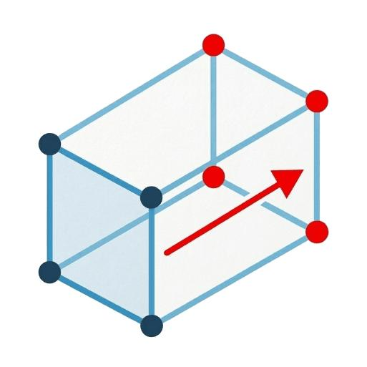
This ray begins at a vertex and immediately extends outside the solid.
For example, a ray may start at the upper corner of a cube and point away from the cube into the surrounding space.
Its endpoint is on the solid, but the rest of the ray lies outside the solid.

B. Ray initially passing through the interior of a solid
# Source: AI Source: Provided by: [Data Path: Persons Table -> ID Column: 1, Name_En Column: Motasem Essam] -> From: [ChatGPT] on [7/25/2026]
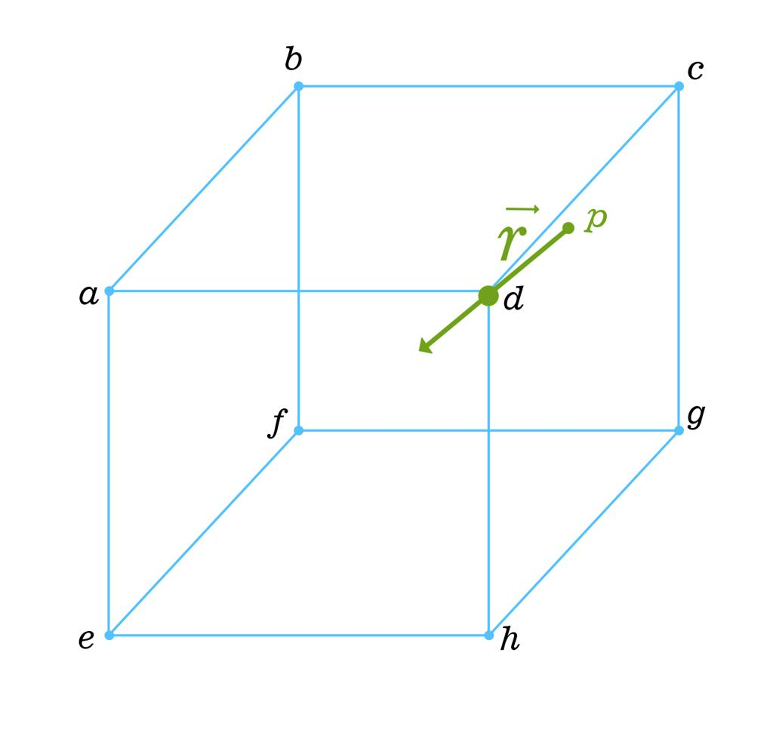
A ray can start at a vertex and travel through the solid's interior before exiting its boundary.
For a cube, a ray directed toward the opposite vertex follows a space diagonal until it reaches that vertex. The ray then continues beyond it.
Unlike the finite space diagonal, the complete ray is infinite.

C. Ray directed along an edge
# Source: AI Source: Provided by: [Data Path: Persons Table -> ID Column: 1, Name_En Column: Motasem Essam] -> From: [ChatGPT] on [7/25/2026]
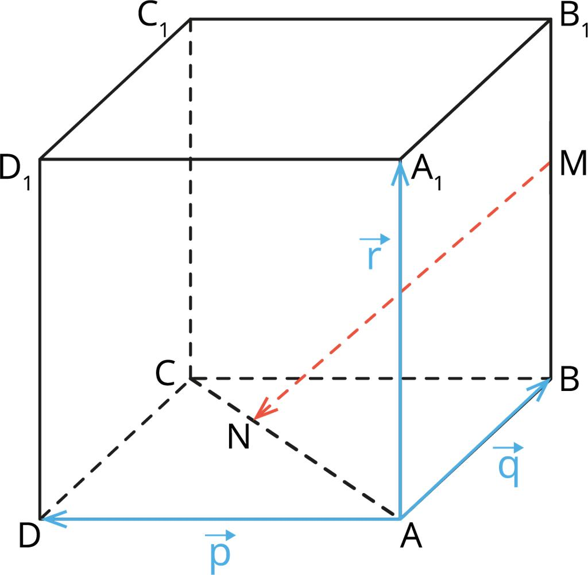
A ray can start at a vertex and follow the same direction as an edge.
It coincides with the edge over the finite edge segment, then continues beyond the adjacent vertex.
The edge is finite; the ray is infinite.

D. Ray lying in the plane of a face
# Source: AI Source: Provided by: [Data Path: Persons Table -> ID Column: 1, Name_En Column: Motasem Essam] -> From: [ChatGPT] on [7/25/2026]
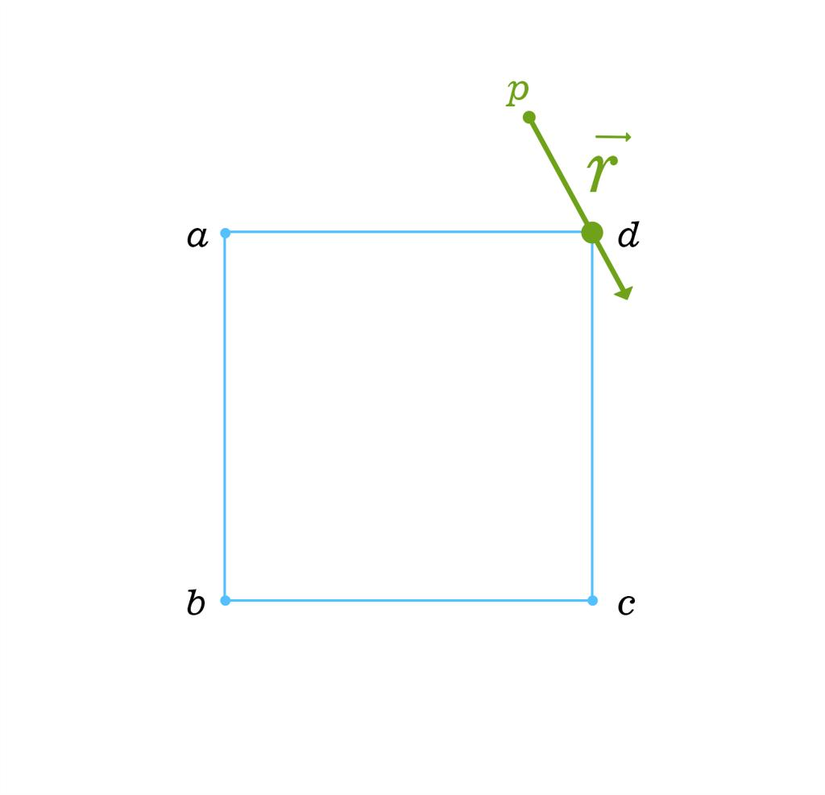
A ray can start at a vertex and lie within the plane containing one of the solid's faces.
The ray may travel across that face and then extend beyond the face's boundary while remaining in the same plane.
It does not necessarily remain on the solid's surface.

E. Ray originating at the apex of a pyramid
# Source: AI Source: Provided by: [Data Path: Persons Table -> ID Column: 1, Name_En Column: Motasem Essam] -> From: [ChatGPT] on [7/25/2026]
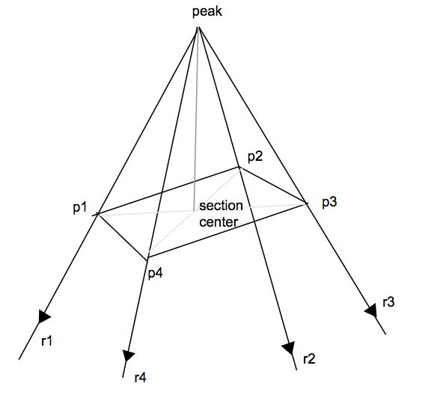
A pyramid's apex is a vertex from which many possible rays can originate.
A ray from the apex may point outward, toward the base, or in another direction through the surrounding space.
If the ray follows the pyramid's altitude, its direction may pass through the interior before reaching the base plane.

Mathematical representations

A. Vector equation
# Source: AI Source: Provided by: [Data Path: Persons Table -> ID Column: 1, Name_En Column: Motasem Essam] -> From: [ChatGPT] on [7/25/2026]
Let the vertex be:
$$A=\left(x_{0},y_{0},z_{0}\right)$$
Let the nonzero direction vector be:
$$d=\left(a,b,c\right)$$
The ray originating at $A$ is represented by:
$$\boxed{r\left(t\right)=A+td, t≥0}$$
The condition $t≥0$ ensures that the ray starts at $A$ and continues only in the specified direction.

B. Parametric equations
# Source: AI Source: Provided by: [Data Path: Persons Table -> ID Column: 1, Name_En Column: Motasem Essam] -> From: [ChatGPT] on [7/25/2026]
The vector equation can be expanded into three coordinate equations:
$$\boxed{\begin{aligned}x&=x_{0}+at \\ y&=y_{0}+bt \\ z&=z_{0}+ct\end{aligned} t≥0}$$
When $t=0$, the point is the original vertex. When $t>0$, the point lies farther along the ray.

C. Ray defined by a vertex and another point
# Source: AI Source: Provided by: [Data Path: Persons Table -> ID Column: 1, Name_En Column: Motasem Essam] -> From: [ChatGPT] on [7/25/2026]
Suppose the vertex is $A$ and the ray passes through a distinct point $B$.
The direction vector is:
$$d=B-A$$
Thus:
$$\boxed{r\left(t\right)=A+t\left(B-A\right), t≥0}$$
For coordinates $A\left(x_{1},y_{1},z_{1}\right)$ and $B\left(x_{2},y_{2},z_{2}\right)$:
$$\boxed{\begin{aligned}x&=x_{1}+t\left(x_{2}-x_{1}\right) \\ y&=y_{1}+t\left(y_{2}-y_{1}\right) \\ z&=z_{1}+t\left(z_{2}-z_{1}\right)\end{aligned} t≥0}$$

D. Direction along an edge of a cube
# Source: AI Source: Provided by: [Data Path: Persons Table -> ID Column: 1, Name_En Column: Motasem Essam] -> From: [ChatGPT] on [7/25/2026]
Consider a cube with one vertex at $A=\left(0,0,0\right)$ and edges parallel to the coordinate axes.
A ray starting at $A$ along the positive $x$-direction is:
$$\boxed{r\left(t\right)=\left(t,0,0\right), t≥0}$$
If the cube's edge length is $a$, the ray follows the cube's edge from $x=0$ to $x=a$, then continues beyond the cube for $x>a$.

Worked examples
# Source: AI Source: Provided by: [Data Path: Persons Table -> ID Column: 1, Name_En Column: Motasem Essam] -> From: [ChatGPT] on [7/25/2026]
Example 1: Write a ray originating at a vertex
A cube has a vertex $A=\left(0,0,0\right)$. A ray starts at $A$ and passes through $B=\left(2,3,4\right)$. Find its vector equation.
Step 1: Find the direction vector.
$$d=B-A=\left(2,3,4\right)$$
Step 2: Write the equation.
$$\boxed{r\left(t\right)=\left(0,0,0\right)+t\left(2,3,4\right), t≥0}$$
Equivalently:
$$\boxed{\left(x,y,z\right)=\left(2t,3t,4t\right), t≥0}$$
The ray begins at $A$ and continues through $B$ and beyond.
Example 2: Find a point on the ray
A ray starts at the vertex $A=\left(1,2,3\right)$ and has direction vector $\left(2,1,4\right)$.
Find the point corresponding to $t=3$.
Step 1: Substitute the parameter.
$$r\left(3\right)=\left(1,2,3\right)+3\left(2,1,4\right)$$
Step 2: Calculate each coordinate.
$$x=1+6=7$$
$$y=2+3=5$$
$$z=3+12=15$$
Answer:
$$\boxed{P=\left(7,5,15\right)}$$
Example 3: Ray following a cube's edge
A cube has side length $5\text{ cm}$ and vertex $A=\left(0,0,0\right)$. A ray starts at $A$ and follows the positive $x$-axis.
Its equation is:
$$\boxed{\left(x,y,z\right)=\left(t,0,0\right), t≥0}$$
- For $0≤t≤5$, the ray follows the cube's edge.
- At $t=5$, it reaches the adjacent vertex.
- For $t>5$, it continues outside the cube.
Conclusion: The ray and edge share a finite portion, but they are not the same geometric object.
Example 4: Ray passing through a solid's interior
A cube has vertices $A=\left(0,0,0\right)$ and $C=\left(4,4,4\right)$ at opposite corners. A ray begins at $A$ and follows the direction toward $C$.
Its equation is:
$$\boxed{r\left(t\right)=\left(0,0,0\right)+t\left(4,4,4\right), t≥0}$$
- At $t=0$, the ray starts at $A$.
- At $t=1$, it reaches $C$.
- For $0<t<1$, it passes through the cube's interior.
- For $t>1$, it continues beyond $C$.
The segment $\overline{AC}$ is the space diagonal, while $\overset{→}{AC}$ is the ray that continues beyond the opposite vertex.

Comparison with related geometric concepts
# Source: AI Source: Provided by: [Data Path: Persons Table -> ID Column: 1, Name_En Column: Motasem Essam] -> From: [ChatGPT] on [7/25/2026]
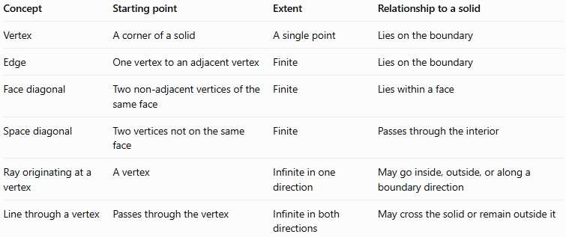
Concept | Starting point | Extent | Relationship to a solid
Vertex | A corner of a solid | A single point | Lies on the boundary
Edge | One vertex to an adjacent vertex | Finite | Lies on the boundary
Face diagonal | Two non-adjacent vertices of the same face | Finite | Lies within a face
Space diagonal | Two vertices not on the same face | Finite | Passes through the interior
Ray originating at a vertex | A vertex | Infinite in one direction | May go inside, outside, or along a boundary direction
Line through a vertex | Passes through the vertex | Infinite in both directions | May cross the solid or remain outside it
Key distinction: A ray is defined by its endpoint and direction, not by the solid itself. Starting at a vertex does not require the ray to remain inside or on the surface of that solid.

Practical applications
# Source: AI Source: Provided by: [Data Path: Persons Table -> ID Column: 1, Name_En Column: Motasem Essam] -> From: [ChatGPT] on [7/25/2026]
- Computer graphics: casting rays from the corners of 3D models to detect intersections.
- Engineering: describing directional paths that begin at a known structural vertex.
- Optics: modeling a light ray emitted from a point located at a corner.
- Geometric modeling: extending edge directions beyond the boundaries of a solid.
- Collision detection: determining whether a ray from a vertex intersects another object.

Key points
# Source: AI Source: Provided by: [Data Path: Persons Table -> ID Column: 1, Name_En Column: Motasem Essam] -> From: [ChatGPT] on [7/25/2026]
- A ray originating at a vertex has its endpoint at a corner of a solid.
- It extends infinitely in one direction.
- Its direction can be inward, outward, or along an edge direction.
- Its vector equation is $r\left(t\right)=A+td$, with $t≥0$.
- A ray that follows an edge continues beyond the finite edge.
- A ray directed through a space diagonal continues beyond the opposite vertex.
- Infinitely many rays can originate at a single vertex.

Conclusion
# Source: AI Source: Provided by: [Data Path: Persons Table -> ID Column: 1, Name_En Column: Motasem Essam] -> From: [ChatGPT] on [7/25/2026]
A ray originating at a vertex is a one-dimensional geometric object that begins at a corner of a three-dimensional solid and extends indefinitely in a chosen direction. It may follow an edge, lie within a face's plane, pass through the interior, or extend outward into surrounding space.

